Capstone Project – DevOps

Project submitted by – Souvik Sarkar
Email – ssouvik154@gmail.com
Phone - 7852856739
Batch – 1

Questions –

Step 1: Jira Workflow
• Each candidate must assign themselves tasks in Jira.
• Track task progress using Jira board (To Do → In Progress → Done).
• Export the board as part of the final submission.

Step 2: GitHub Workflow
• Clone the GitHub repository: https://github.com/akshu20791/Book-My-Show/
• Create a feature branch and make changes.
• Push changes and raise a Pull Request (PR).
• Review peers' PRs and approve before merging into the main branch.
• Submit the final PR link as deliverable.

Step 3: Jenkins CI/CD Pipeline
Pipeline stages to implement:
1. Clean Workspace
2. Checkout Code from GitHub
3. SonarQube Analysis (Quality Gate)
4. Install Dependencies (NPM)
5. Trivy FS Scan (Optional)
6. OWASP Dependency Check (Optional)
7. Docker Build & Push to DockerHub (via Jenkins)
8. Deploy to Docker Container
9. (Optional) Deploy to Kubernetes (EKS)
10. Email Notification on build result
Note: Candidates must implement this pipeline using a Jenkinsfile and submit the Jenkinsfile
as a deliverable.

Step 4: Docker Deployment
• Candidates must write their own Dockerfile to build the BMS app image.
• Build Docker image and push to DockerHub via Jenkins.
• Run container locally and validate accessibility on port 3000.

Step 5: Kubernetes Deployment (EKS)
• Candidates must write their own Kubernetes manifests (deployment.yaml, service.yaml).
• Deploy the application on EKS cluster.
• Expose service using NodePort or LoadBalancer.
• Validate deployment using 'kubectl get pods' and 'kubectl get svc'.

Step 6: Monitoring & Observability
• Install Prometheus and Node Exporter to collect metrics.
• Integrate Jenkins metrics into Prometheus.
• Install Grafana, configure Prometheus as a data source.
• Add dashboards for Node health and Jenkins performance.
• Submit Grafana screenshots in deliverables.

Final Deliverables
1. Jira Board Export (task progress).
2. GitHub PR link.
3. Jenkins pipeline execution logs.
4. Jenkinsfile (mandatory).
5. SonarQube Quality Gate report.
6. (Optional) Trivy/OWASP reports.
7. DockerHub repository link.
8. Dockerfile (mandatory).
9. EKS deployment proof (kubectl outputs).
10. Kubernetes manifest files – deployment.yaml and service.yaml (mandatory).
11. Prometheus & Grafana screenshots.
12. Email notification screenshot.
13. Final summary report (Word/PPT)

Forked github repo –
https://github.com/bikssbunny/Book-My-Show-biks.git

1st Task
Main objective is to manage tasks using an Jira board
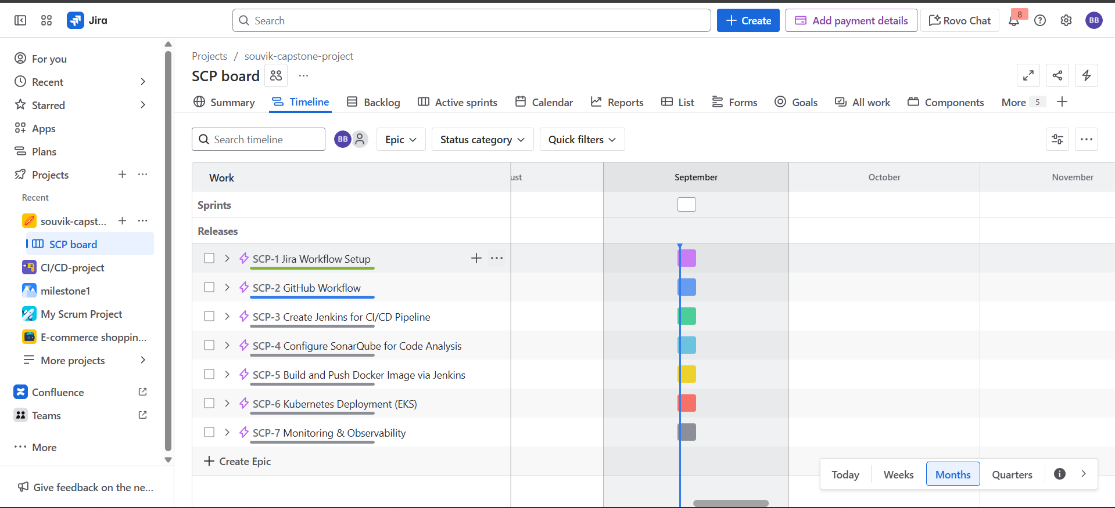
Creating and Managing a Scrum Board in Jira
- Set Up a Scrum Board
  - Log in to Jira and select “Create Project.”
  - Choose the “Scrum” project template.
  - Choose company managed.
  - Name your project (capstone-souvik) and finish setup.
  - Then go to timeline and create new epics and assign subtasks within
  - Organize them into Epics and Stories if needed for structure.
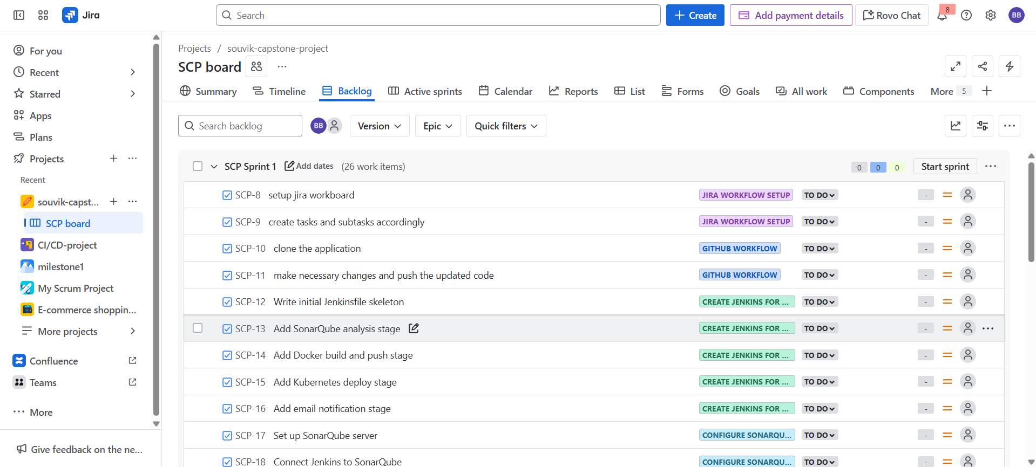
- Planning a Sprint
  - Select issues from the backlog and add them to a new Sprint.
  - Start the Sprint issues will now show in the “Active Sprint” board.
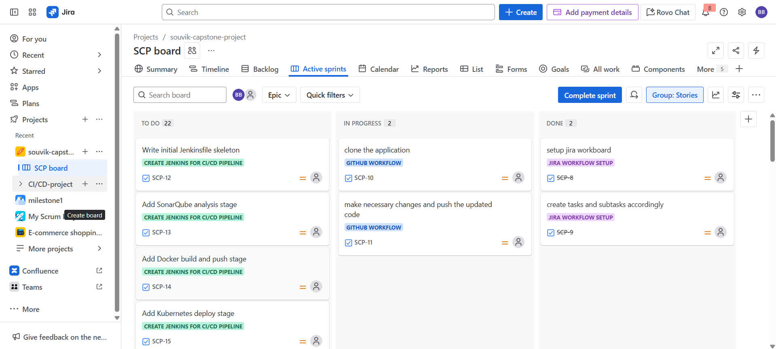
- Track Task Progress
  - Move cards between columns (To Do, In Progress, Done) by drag-and-drop.
  - Add comments, change assignee, or update status as work is completed.

2nd Task
Main objective is to Use GitHub for code collaboration and version control.
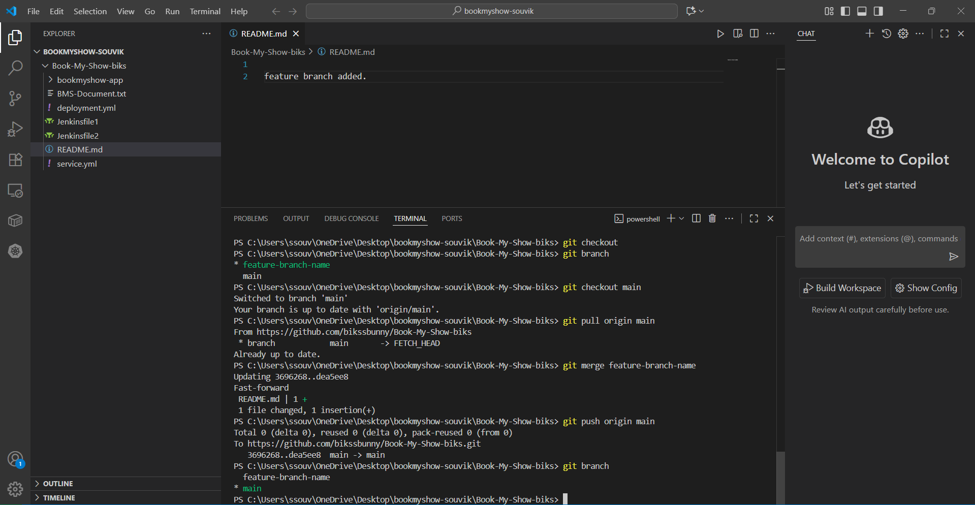
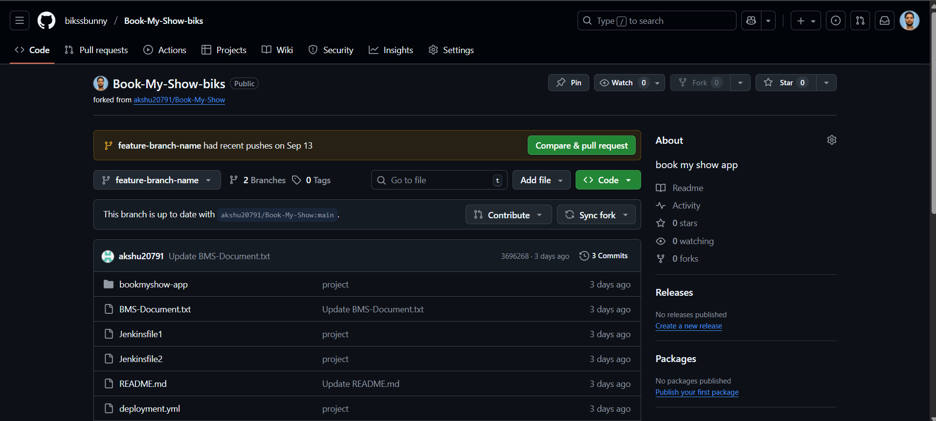
Main objective is to first follow the few steps –
  - First fork the repo to our github repo.
  - Then open it in your local browser and clone the forked repo by command “ git clone https://github.com/bikssbunny/Book-My-Show-biks.git “
  - Then make a feature branch and make some changes to get the pull request.
  - After that go to our github repo and the compare & pull request will appear and follow the ahead steps
  - Then merge pull request
  - After that we’ll be seeing this interface after completion of task.
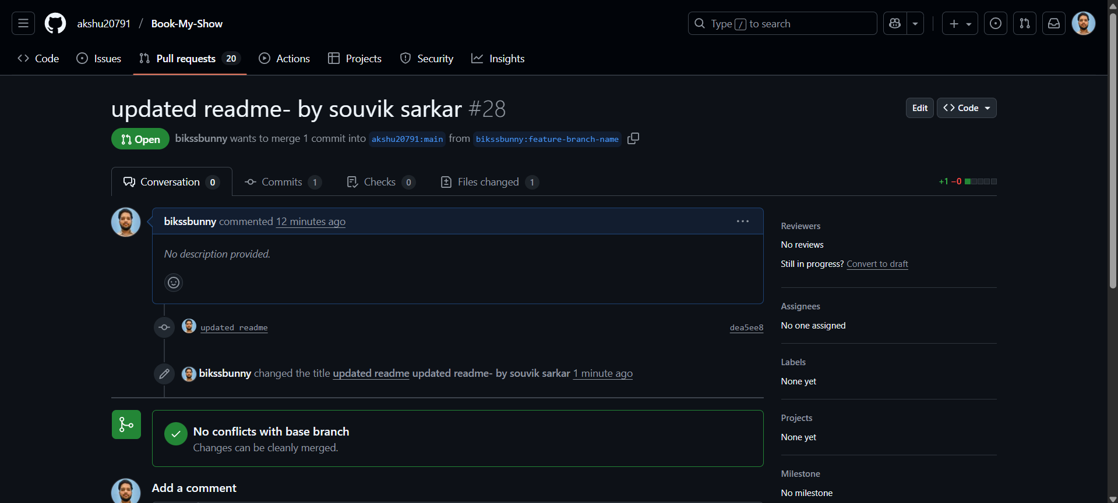
The github pull request URL link –
- https://github.com/akshu20791/Book-My-Show/pull/28
Then update in the jira board as you’ve completed your task 2 so drag and drop it into done from progress
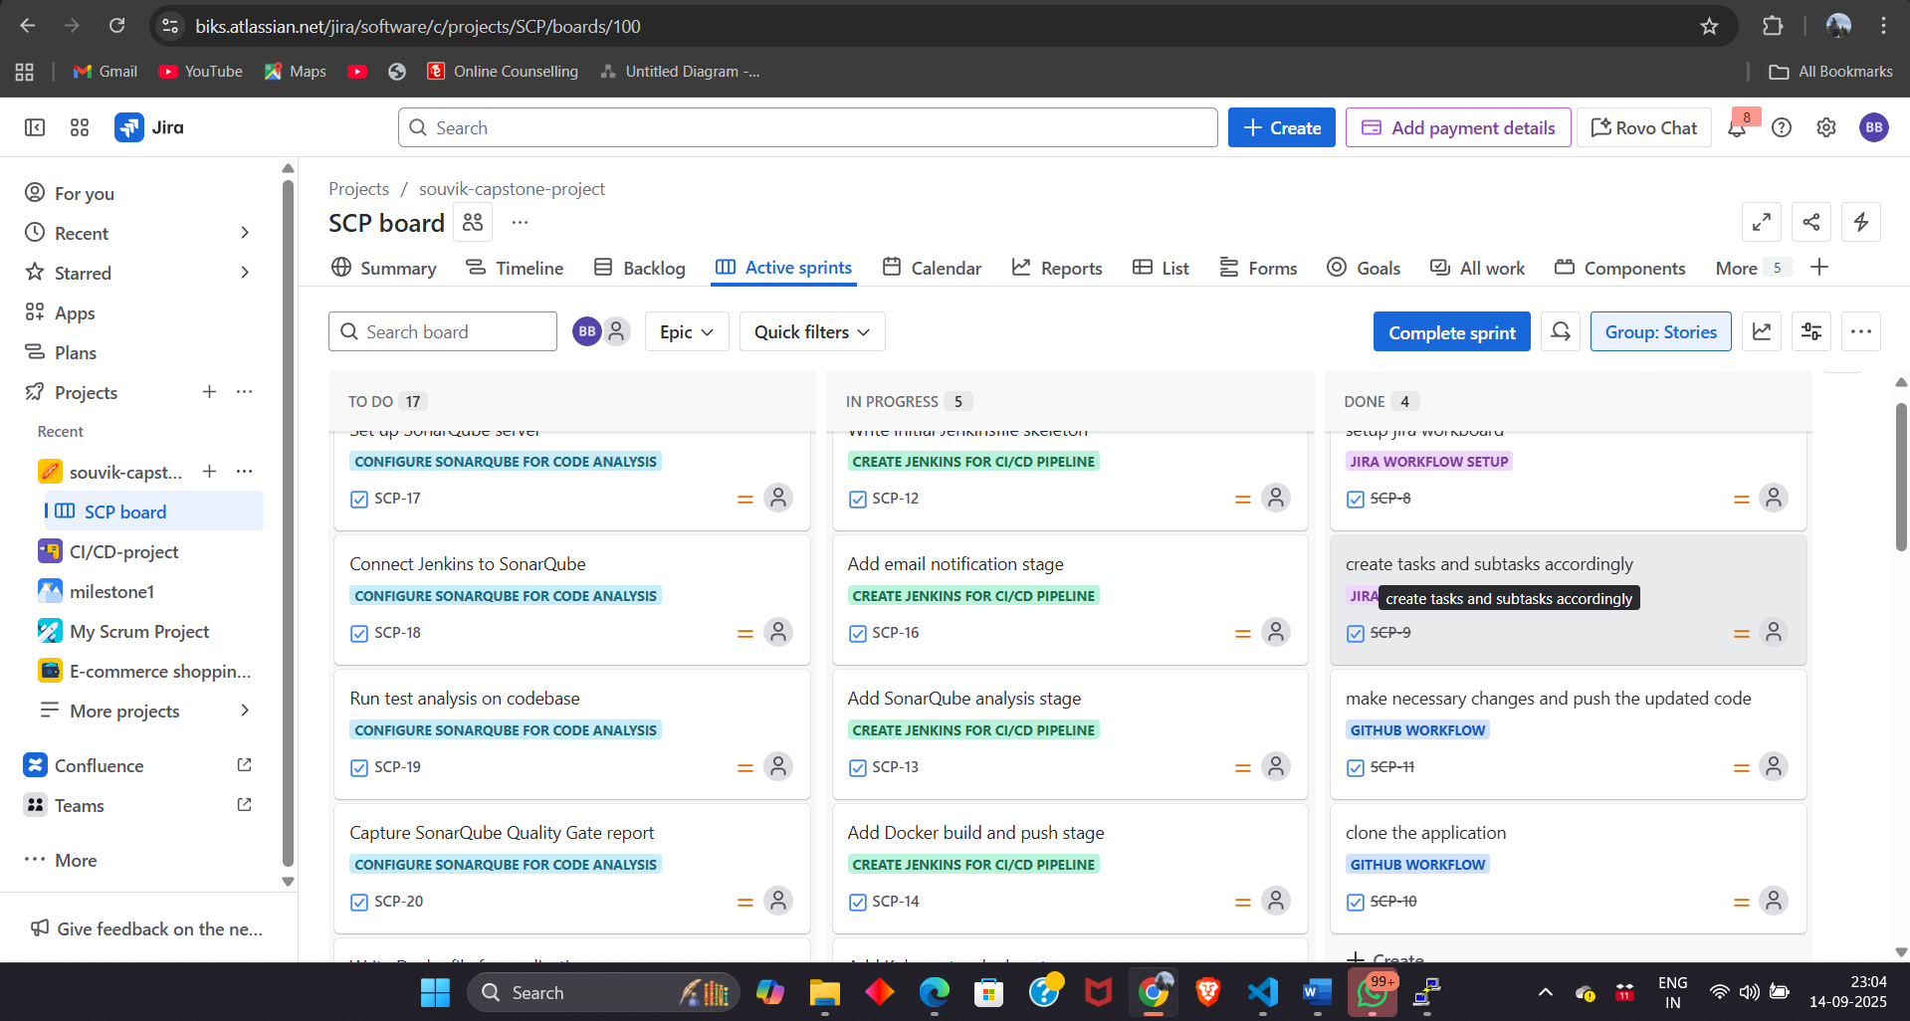

3rd Task
Main objective : Automate the entire build-test-deploy workflow using Jenkins.
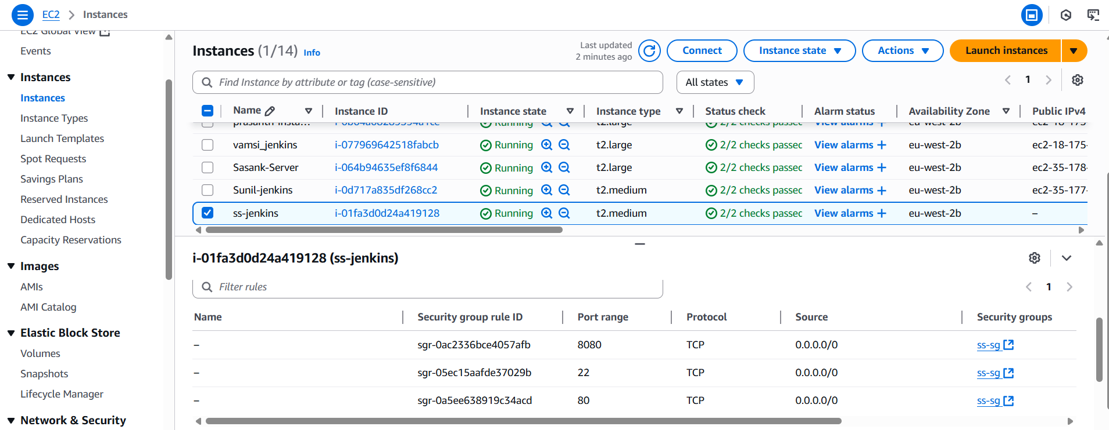
  - Create an instance in name of ss-jenkins
  - After creating the instance connect it via ssh client
  - Install all the pre requisites for the running of Jenkins , like java, npm, docker for sonarqube , Jenkins installations, node js, Kubernetes.
  - Check for Jenkins status after that access it through public-ip:8080
  - Do mind to allow the necessary ports in inbound rules.
  - After that access sonarqube by pulling docker image of sonarqube community lts and access it through public-ip:9000
  - Jenkins integrates with SonarQube to scan the codebase for bugs, vulnerabilities, code smells, and maintainability issues.
  - Jenkins uses the Dockerfile you created to package the application into an image, and then pushes it to DockerHub (your repository).
  - The Docker image is run as a container on the Jenkins server or another node, exposing the app on a specific port.
  - Create credentials for docker ( docker token ) , sonarqube token and email integration for Jenkins setup
  - After every setup jenkins in manage Jenkins section ( tools , credentials and system and installing necessary plugins) well create a new pipeline and build it for the continuous deployment.

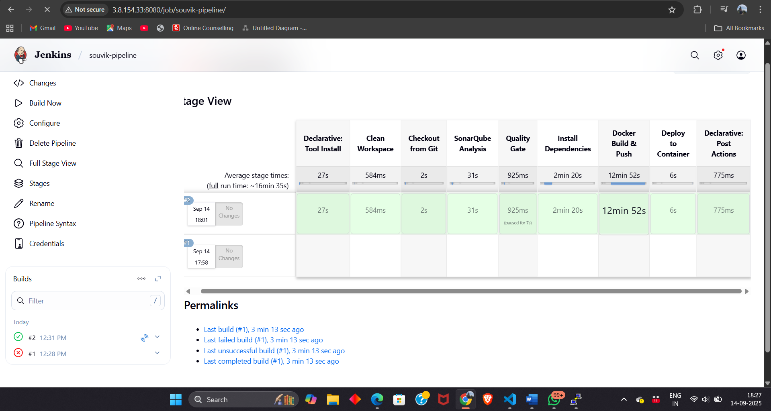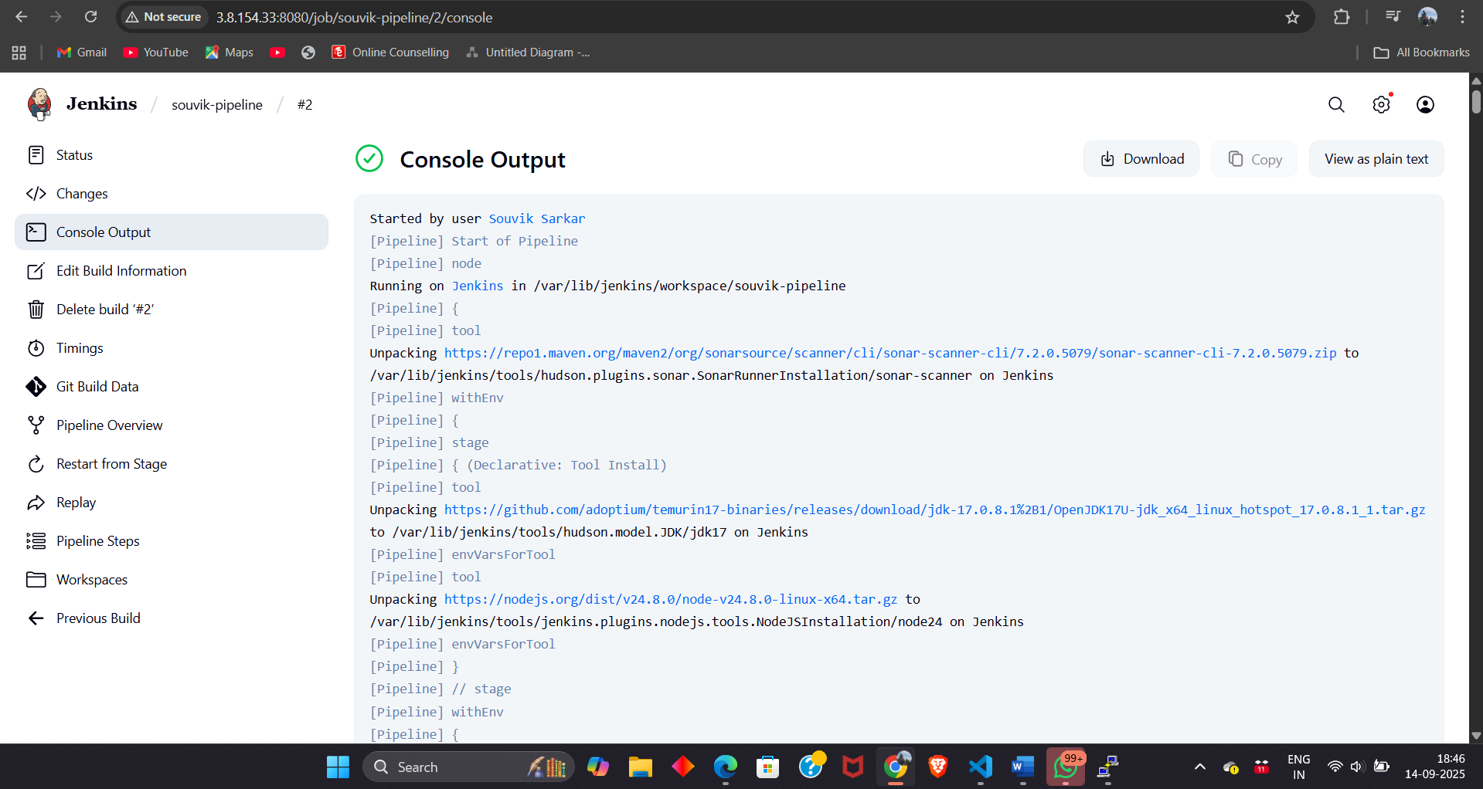

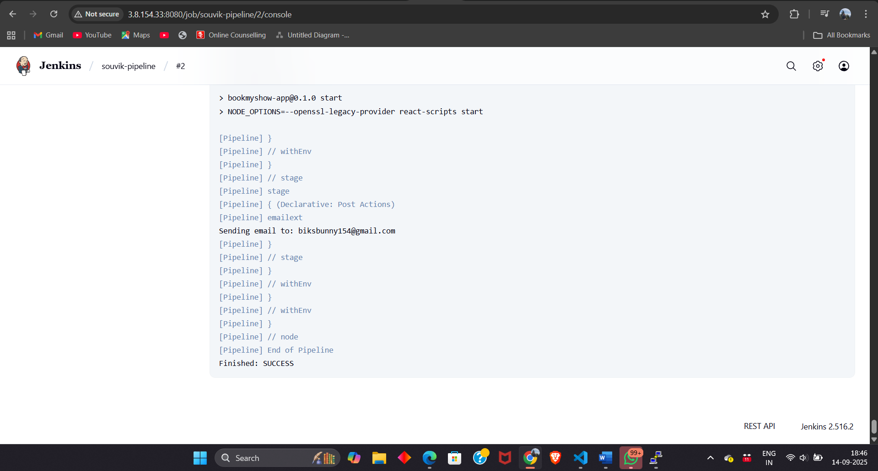

  - After the pipeline got build we can check the code quality in sonarqube and we’ll be pushing the docker image into our docker repository and email of successful
  - In the stage view we can see stage getting passed and which shows successful deployment
  - In mail also a success message pops up after complete success of the pipeline build.

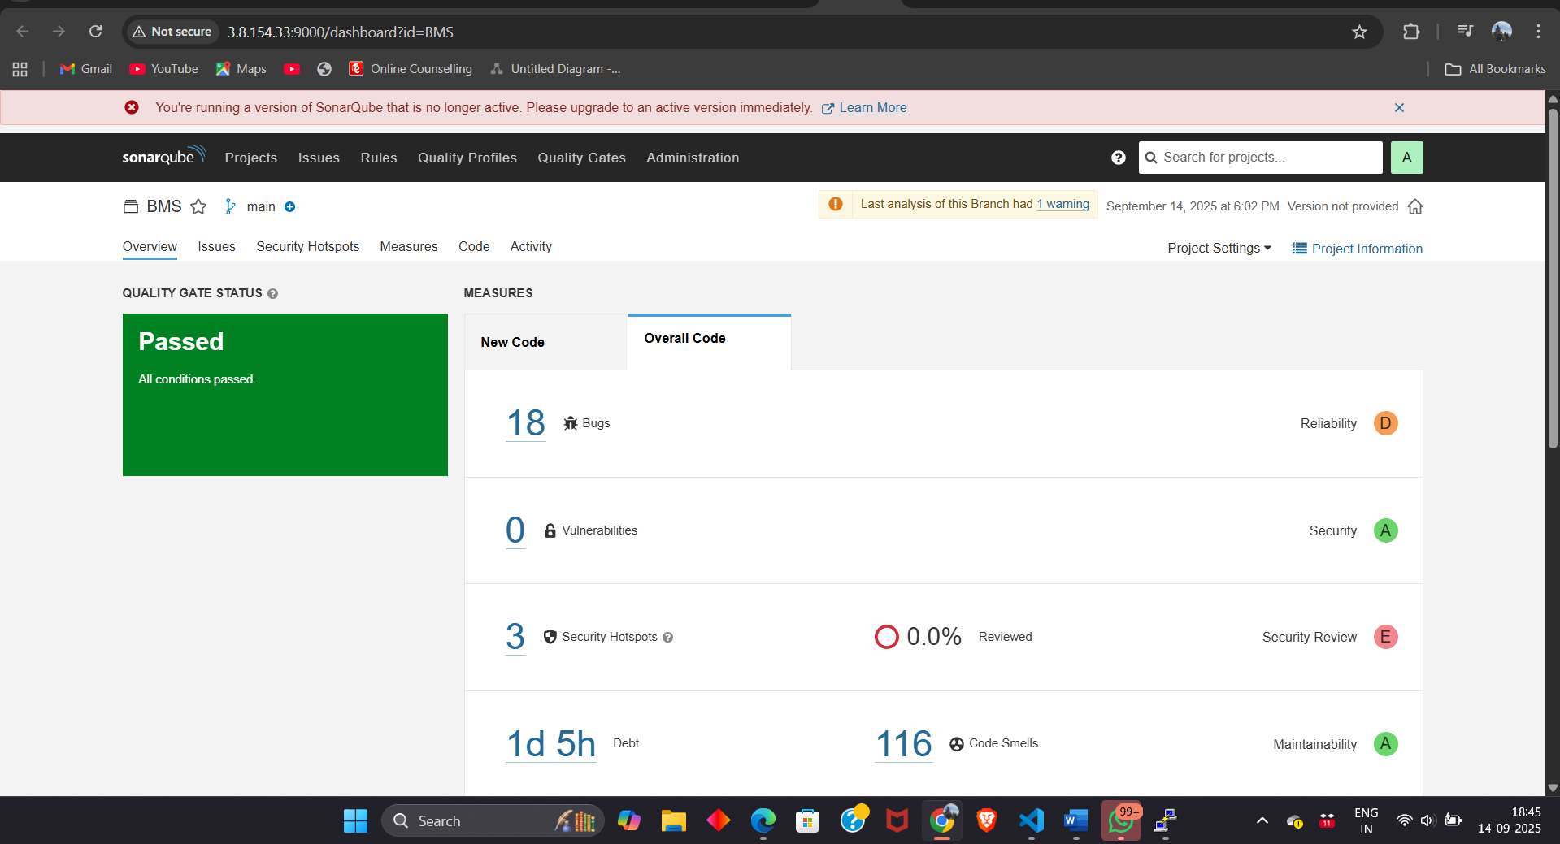
  - Check in sonarqube for the codecodebase for bugs, vulnerabilities, code smells, and maintainability issues andcode quality checks.
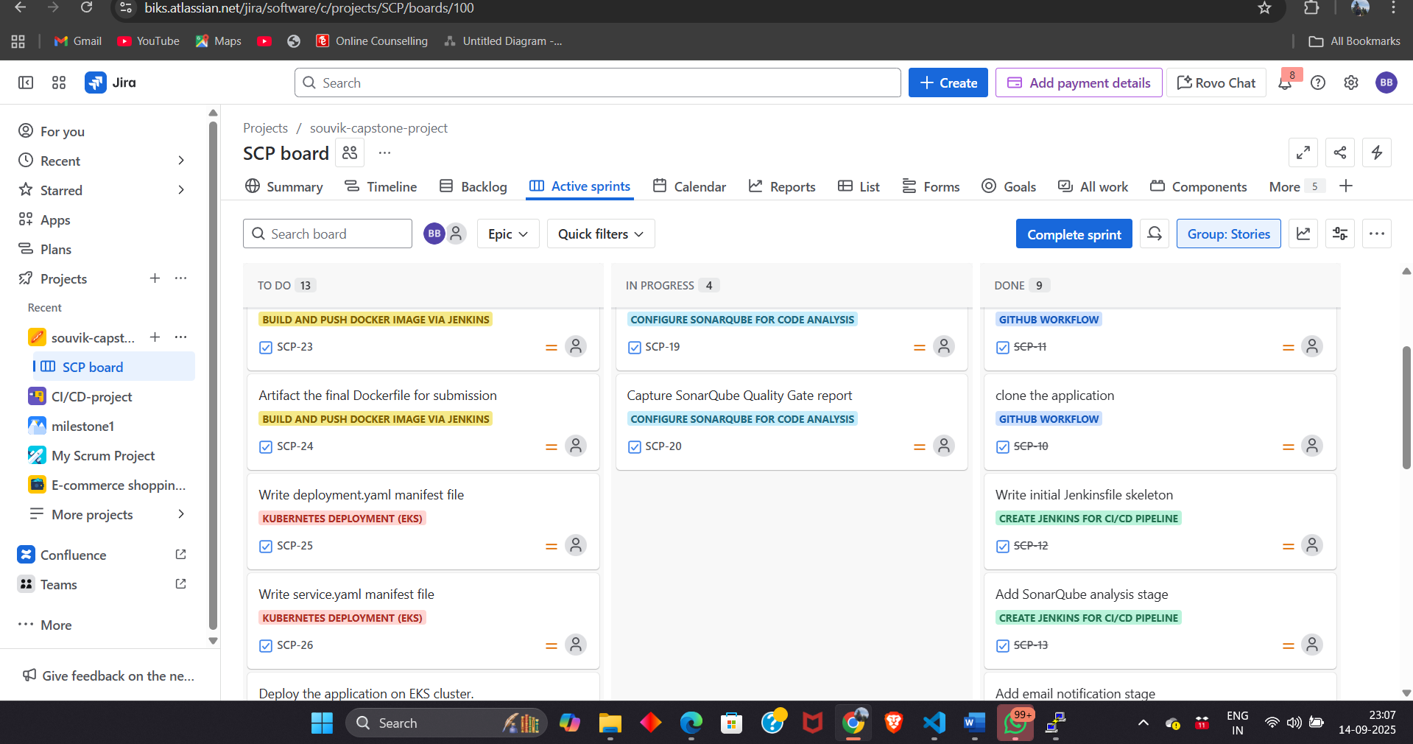
Similarly in last step after completion of task 2 we would manually drag n drop the tasks completed from in progress to done for completion of the task.

4th Task
Main objective is to containerize the application
- Write your own Dockerfile to package the BookMyShow app.
- Jenkins will build the Docker image and push it to DockerHub.
- Run the image locally to check if the app runs properly (port 3000).
- Provides portable, consistent runtime environment.
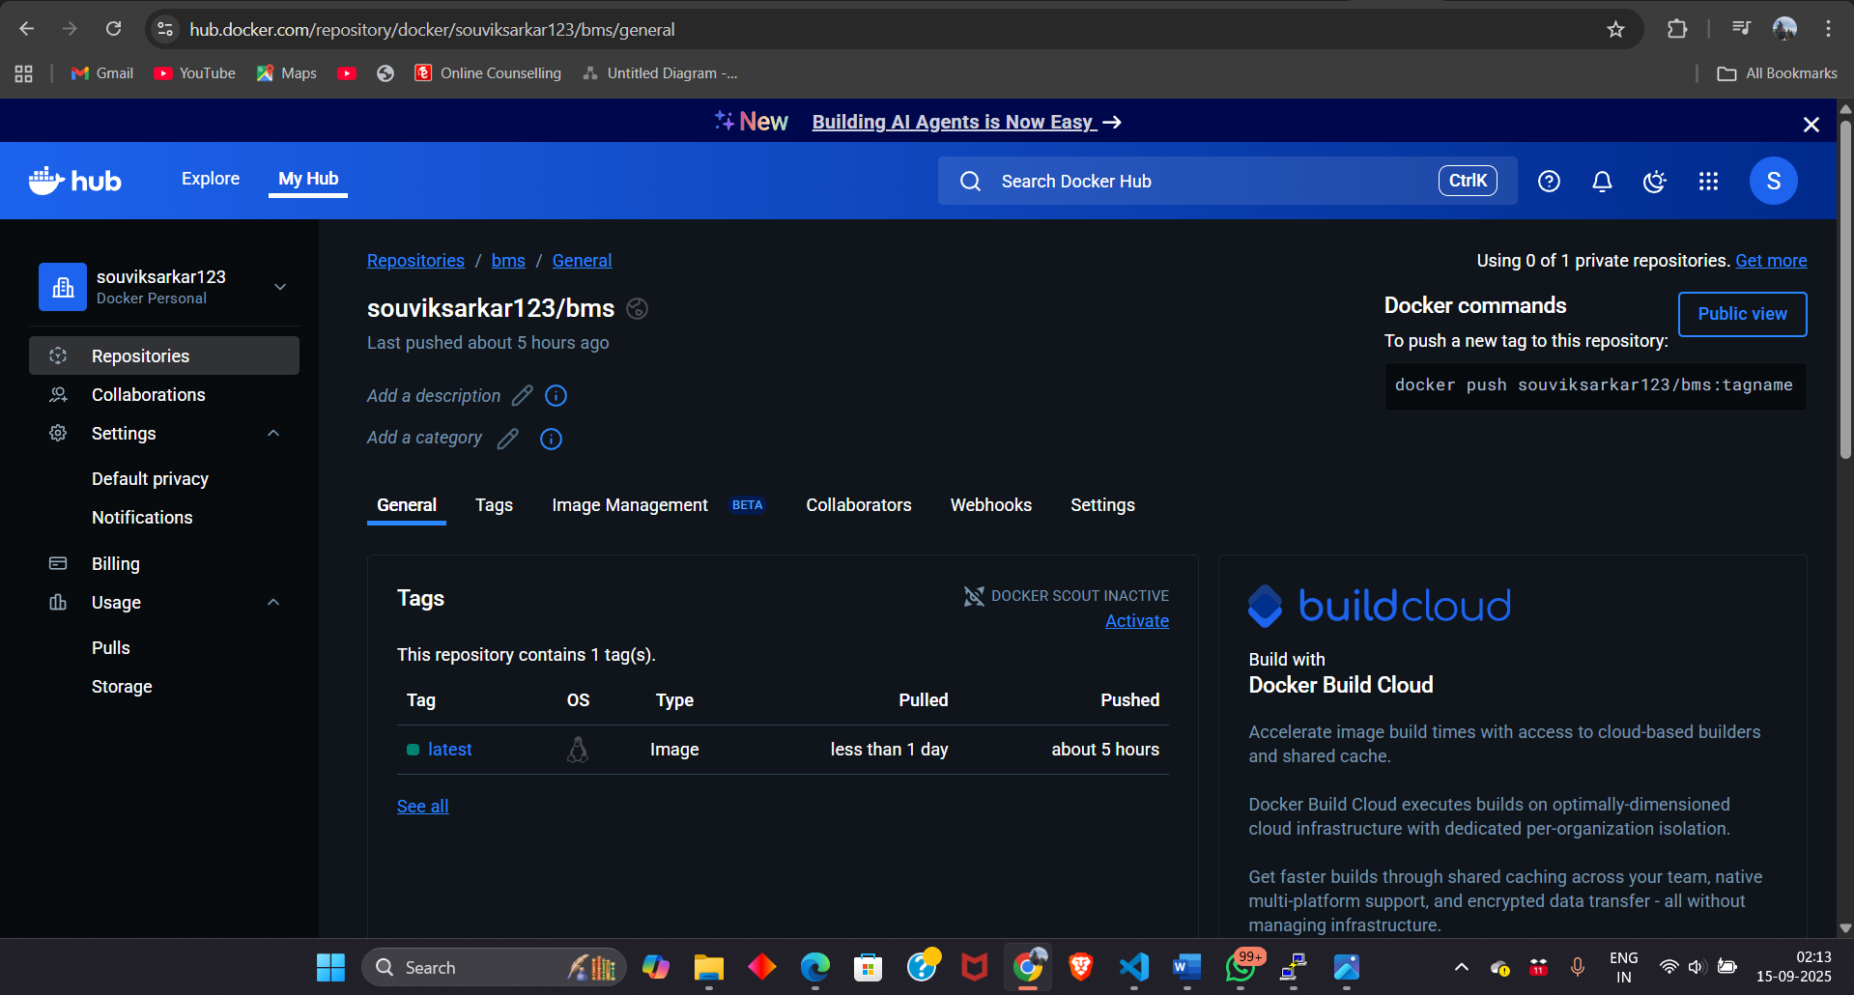
https://hub.docker.com/repository/docker/souviksarkar123/bms/general - Docker hub repository link of pushed docker image
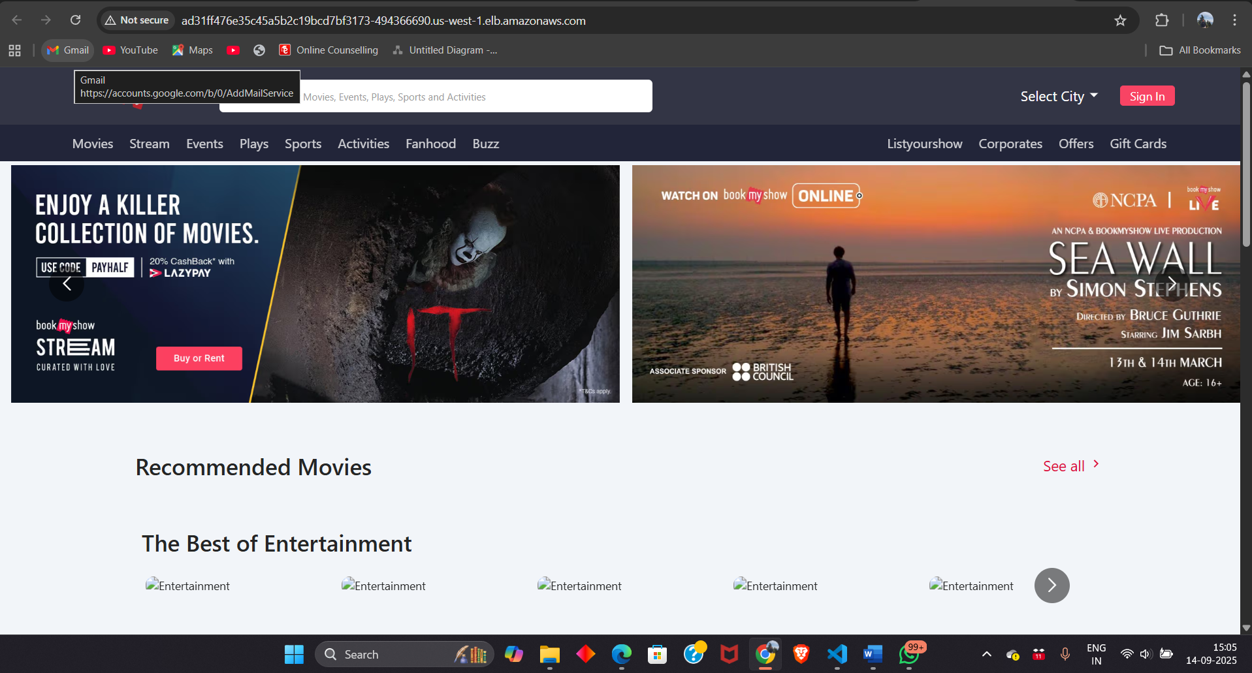
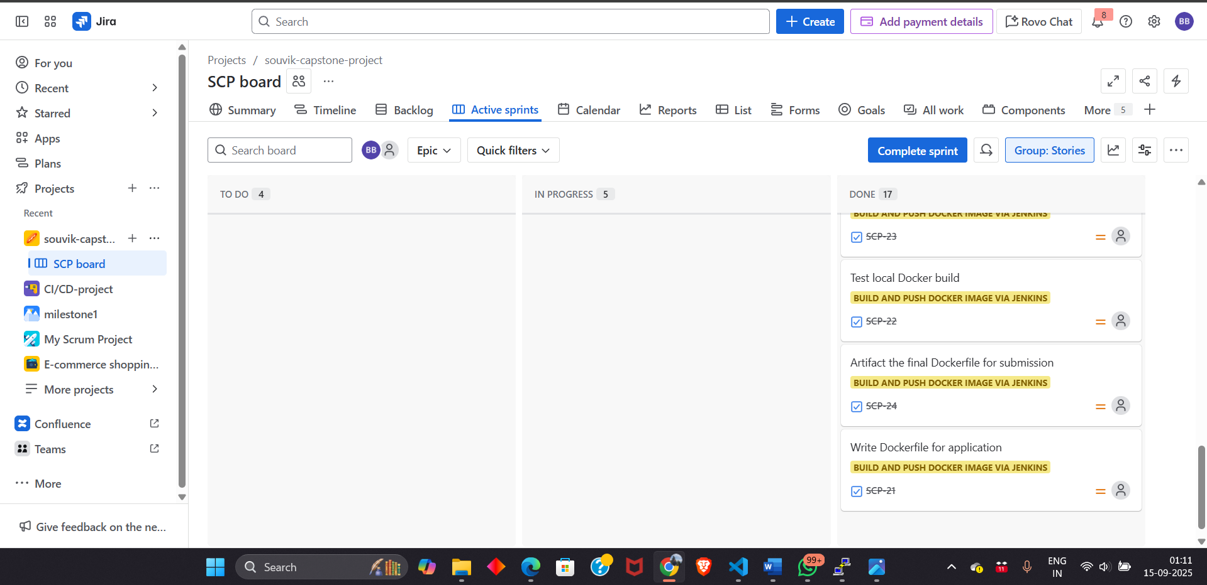
Similarly like last task update the jira board.

5th Task
Main objective Deploy app to a production-like environment.
- Create an EKS cluster
- Install all pre requisites and set the region carefully
- Create a namespace and folder of your name and inside that folder create the manifests file
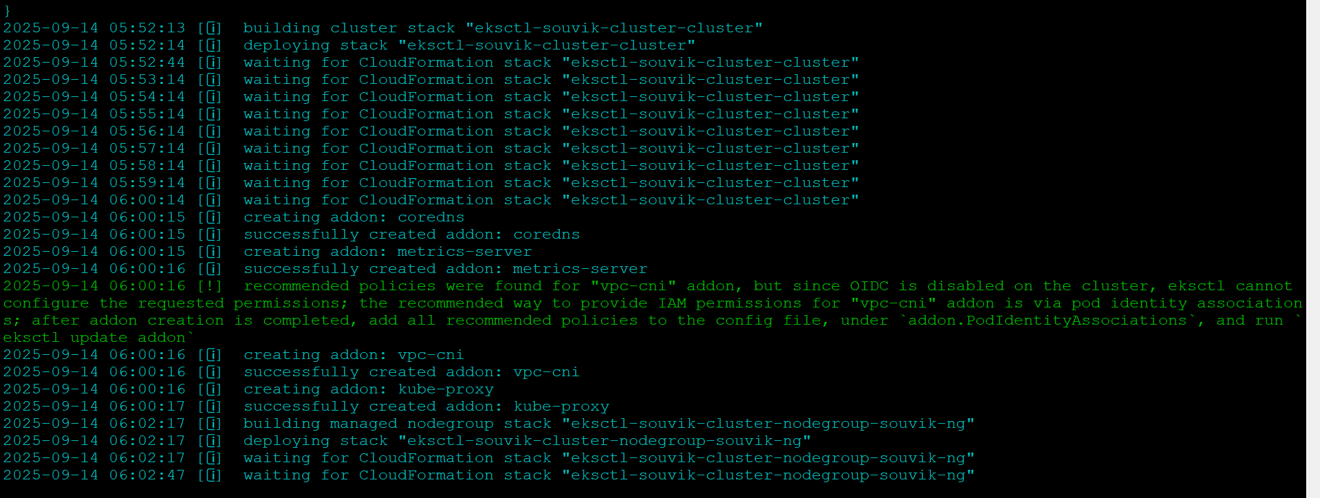
- After successful creation of cluster now we are able to apply the deployment.yaml file and service.yaml file for accessing the website.
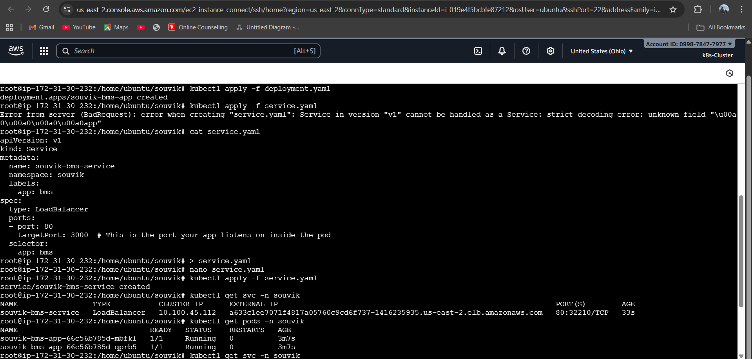
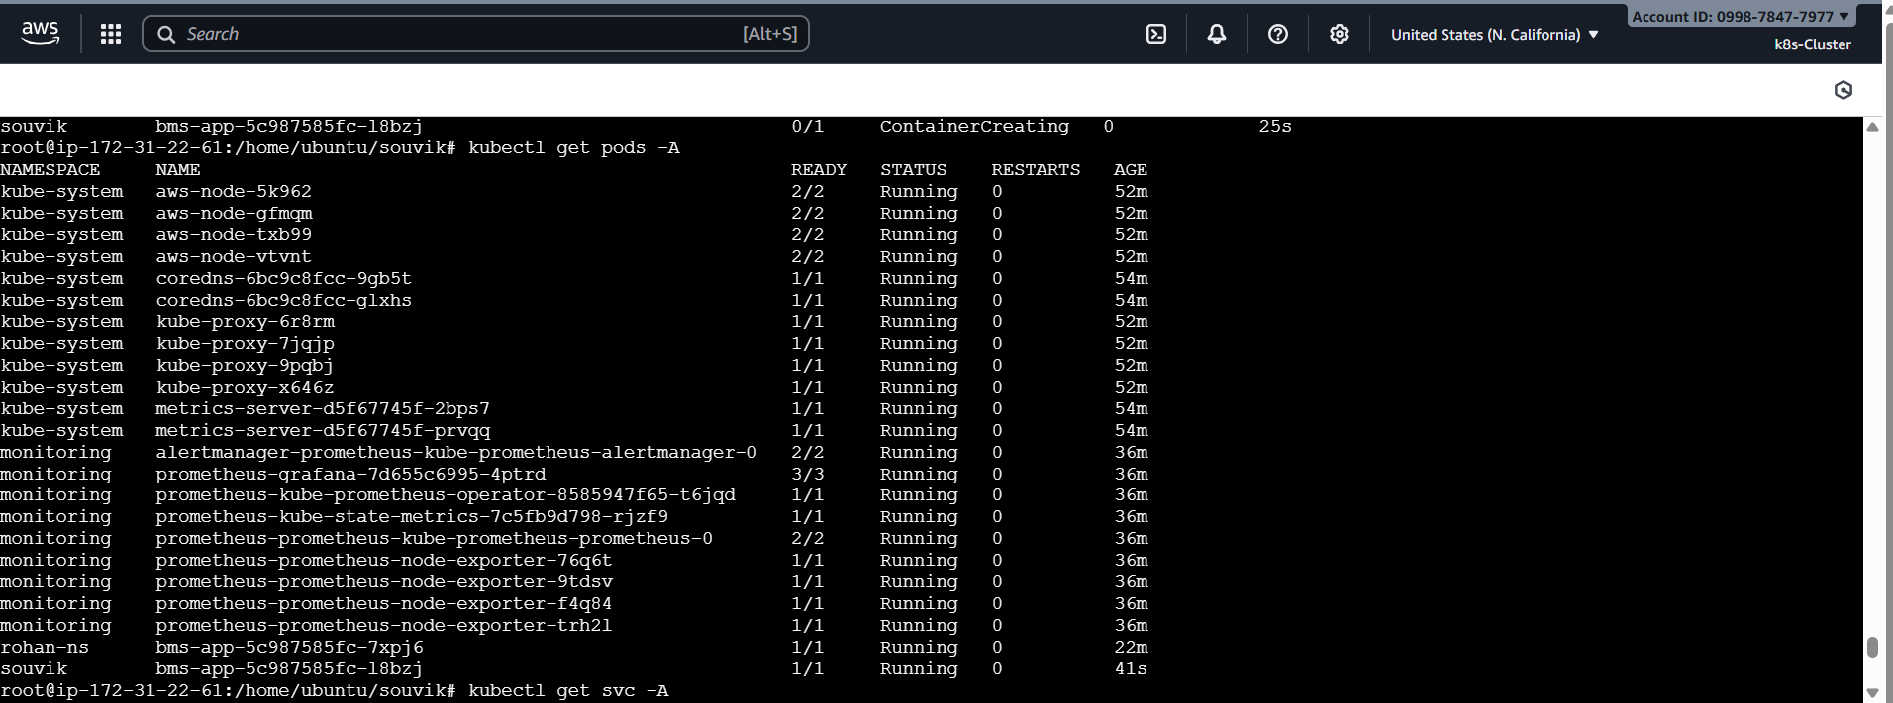
- After applying the 2 manifests files we can now access the kubectl commands
- The command “ kubectl get svc -n souvik “ to get all the services inside the namespace souvik
- The command “kubectl get pods -n souvik” to get all the pods running inside the container after applying deployment.yaml file.
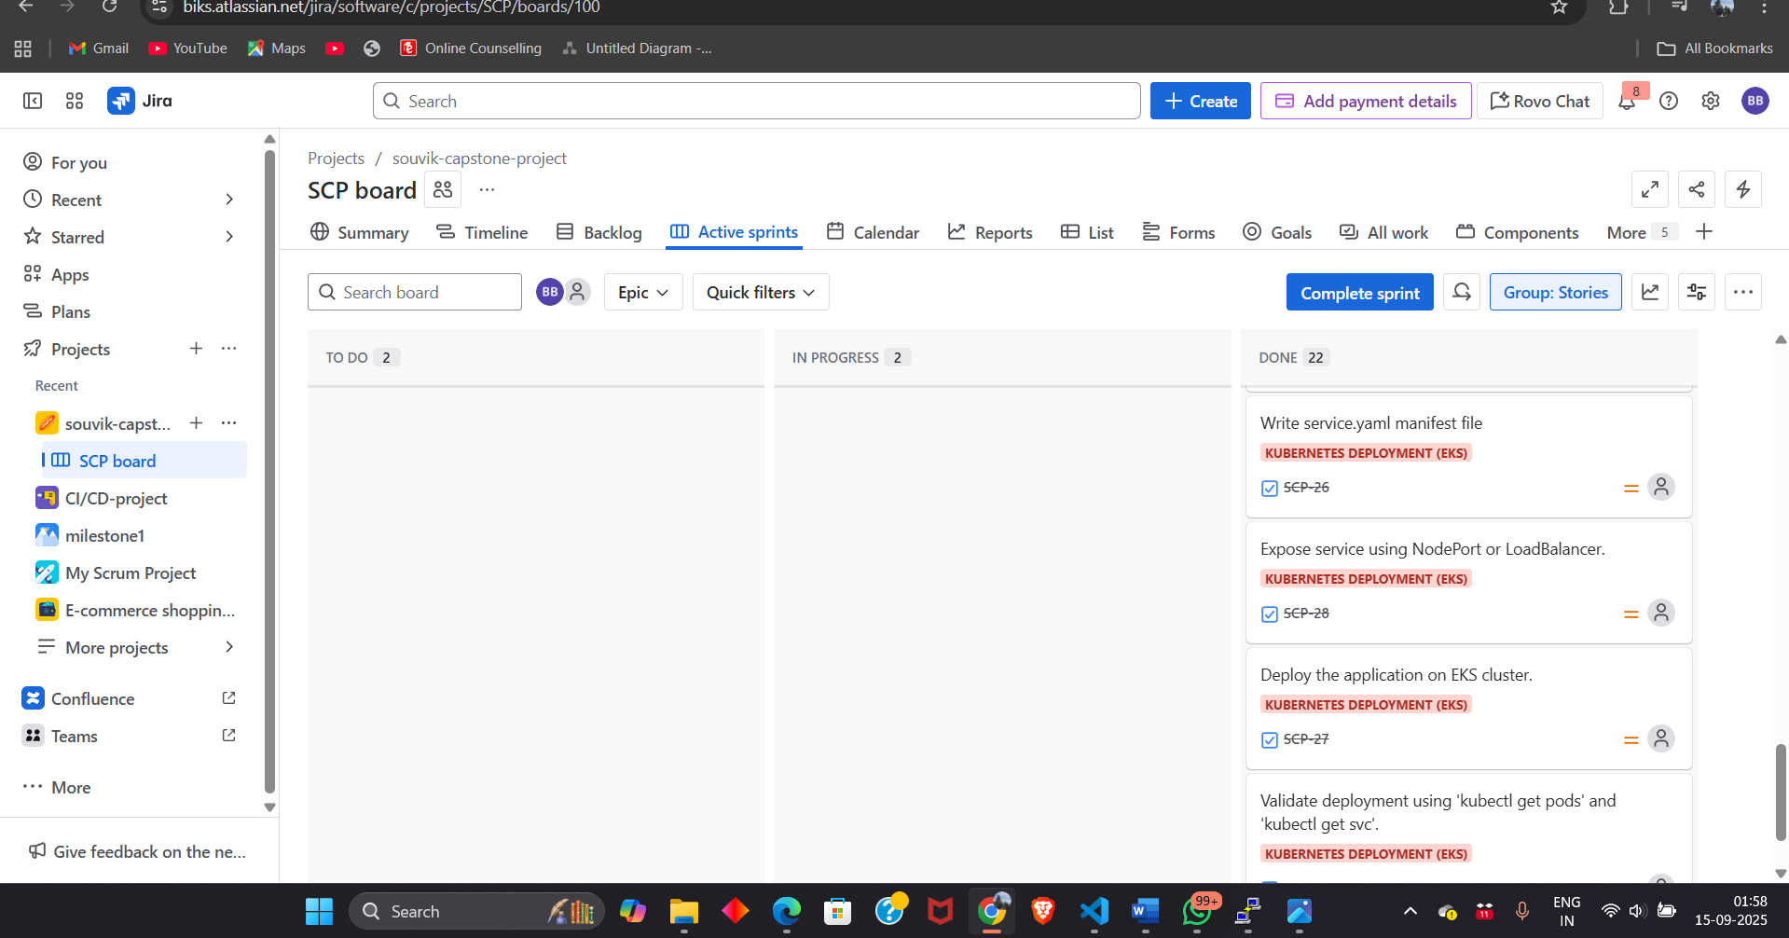
Go to jira board and update the board by completing the task.

6th Task
Main objective is to track performance and health of the system through monitoring tools
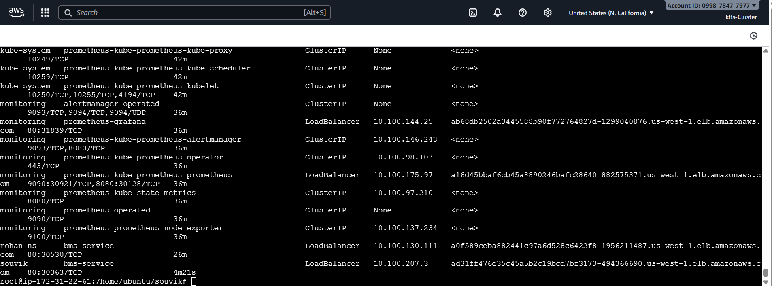
- After all the deployment run all the monitoring commands to install and access Prometheus and Grafana through command “kubectl get all -A” to find the external ip of Prometheus and Grafana.
- Just copy the external ip of Grafana and Prometheus and open it on new tab
- To access Prometheus then externap-ip:9090
- And to access Grafana then external-ip:80
- And similarly access the website by the namespace’s external-ip

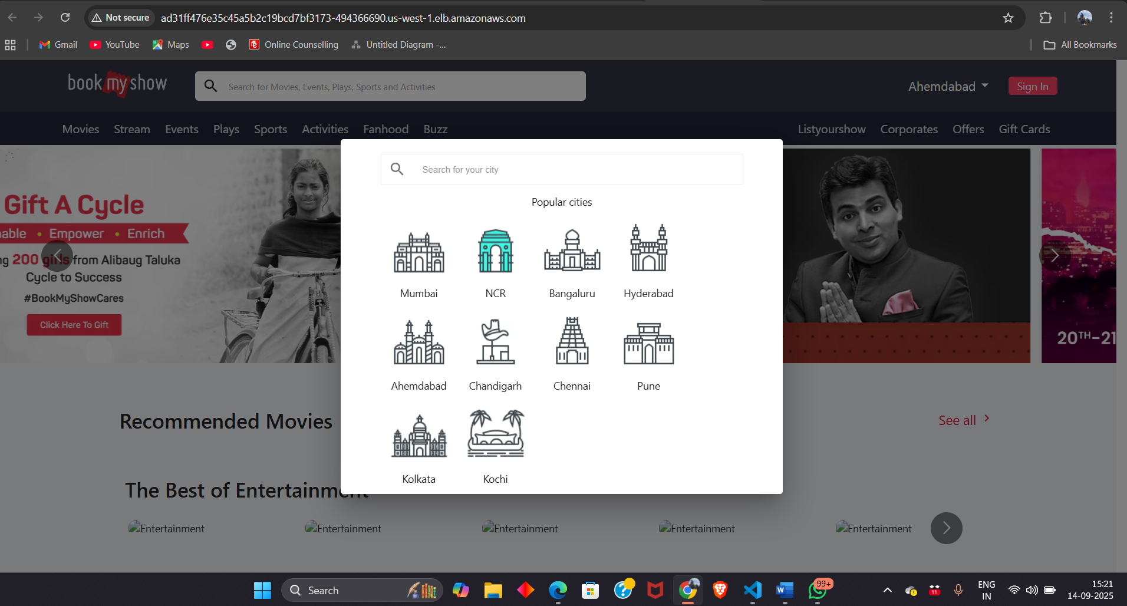
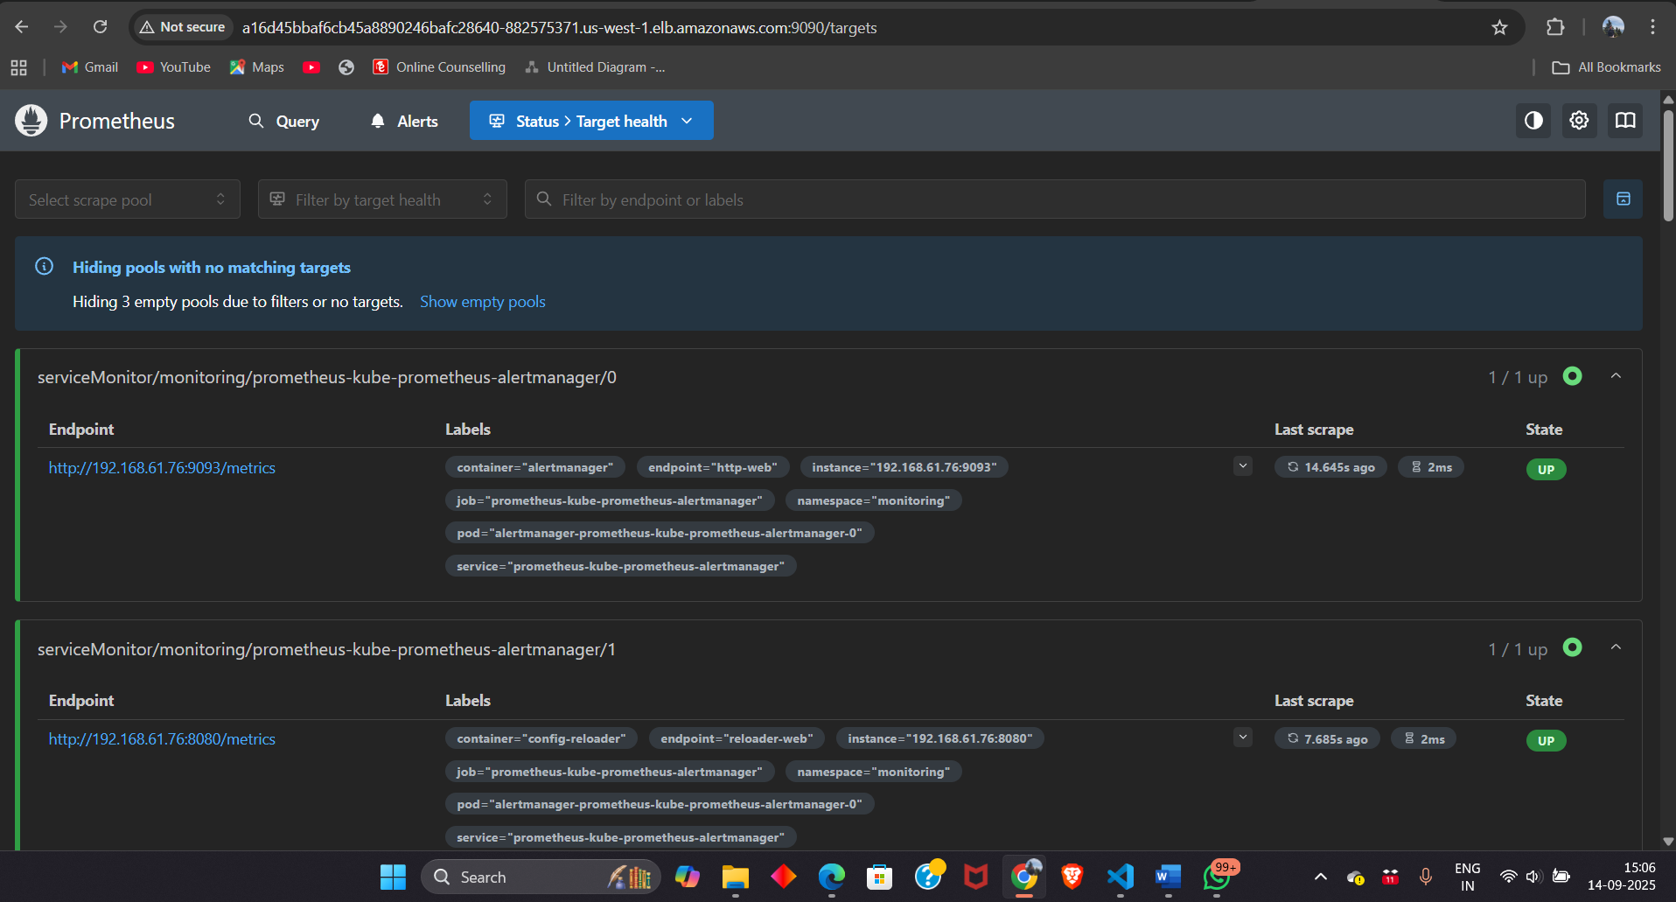
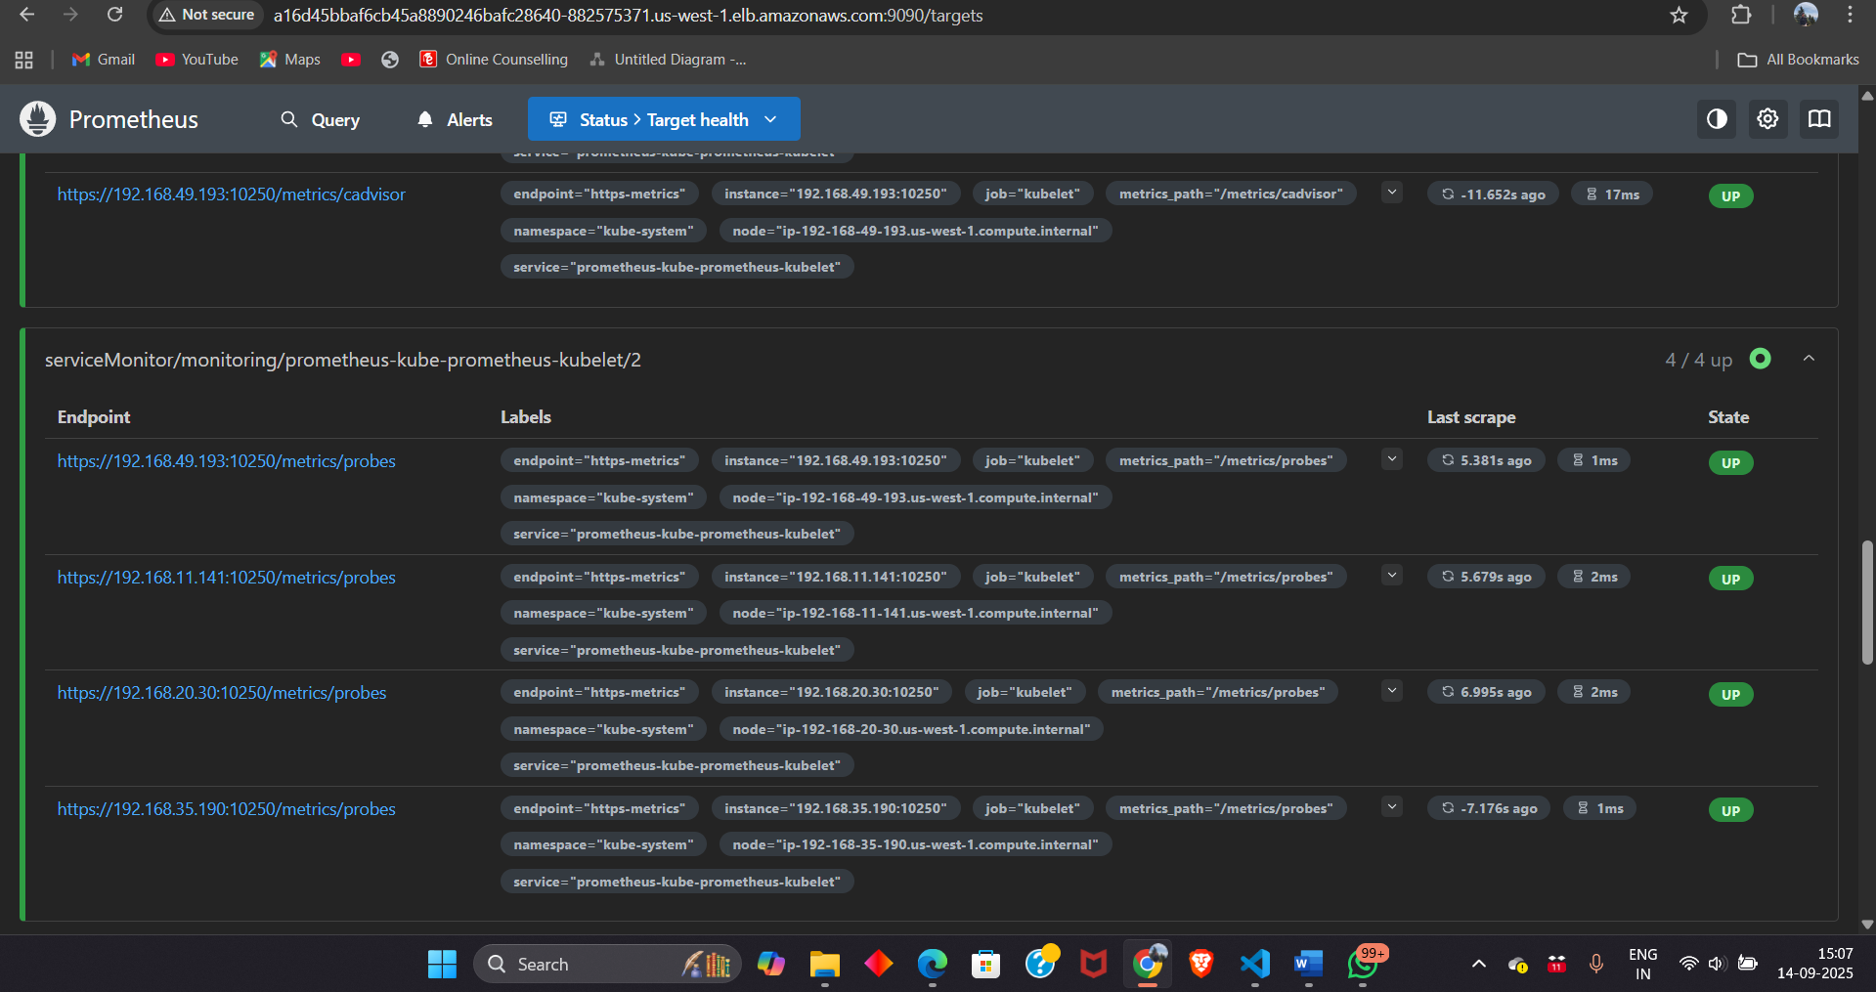

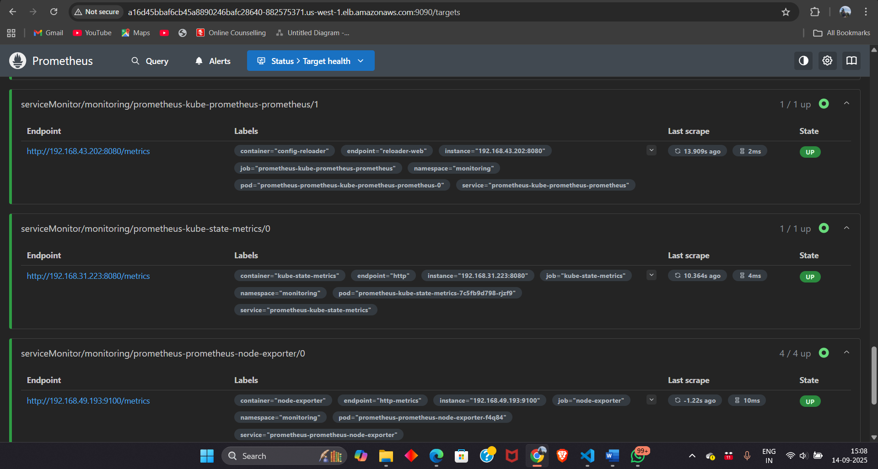
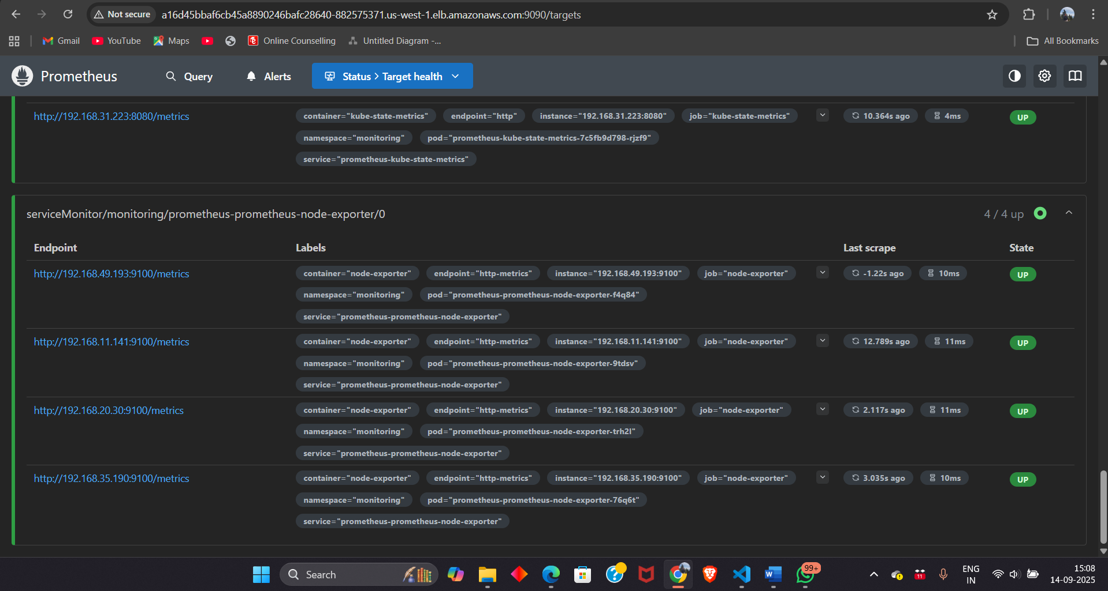
- Access Prometheus by login in and check target health.

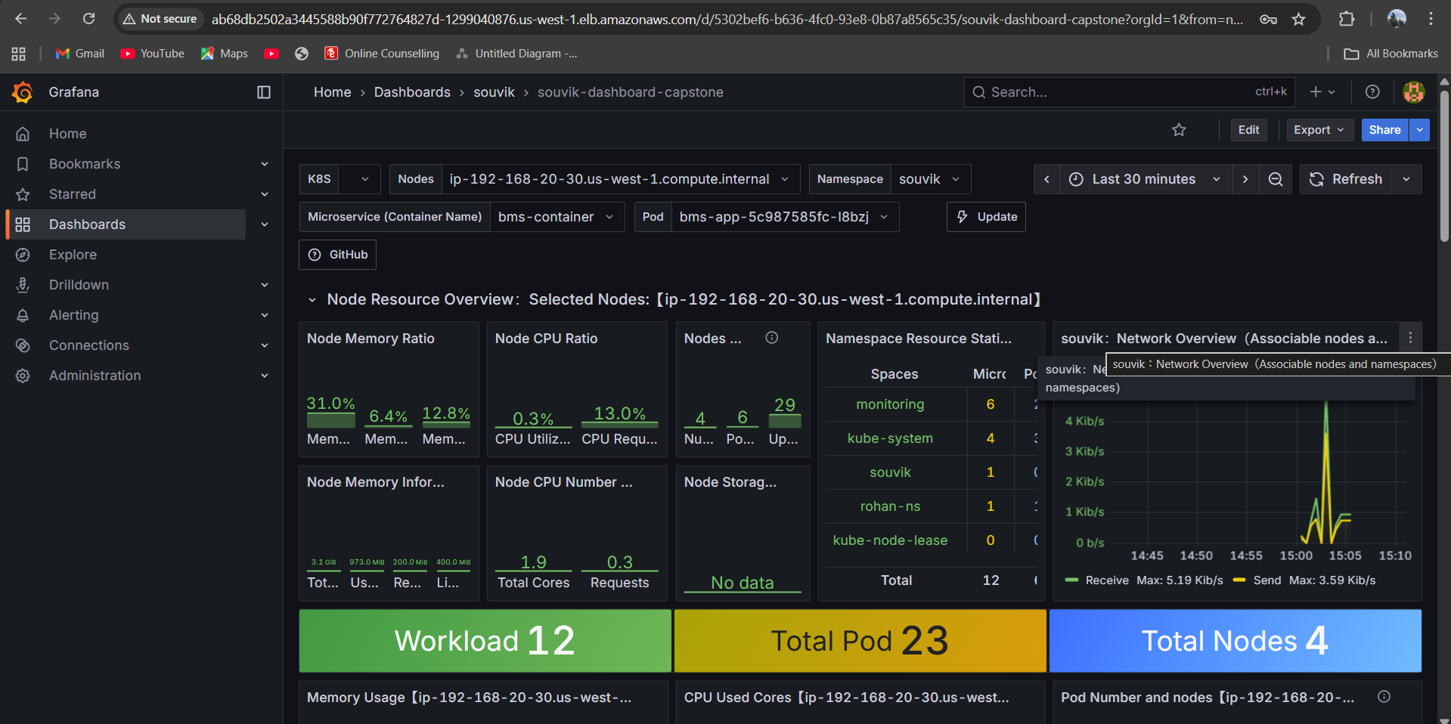
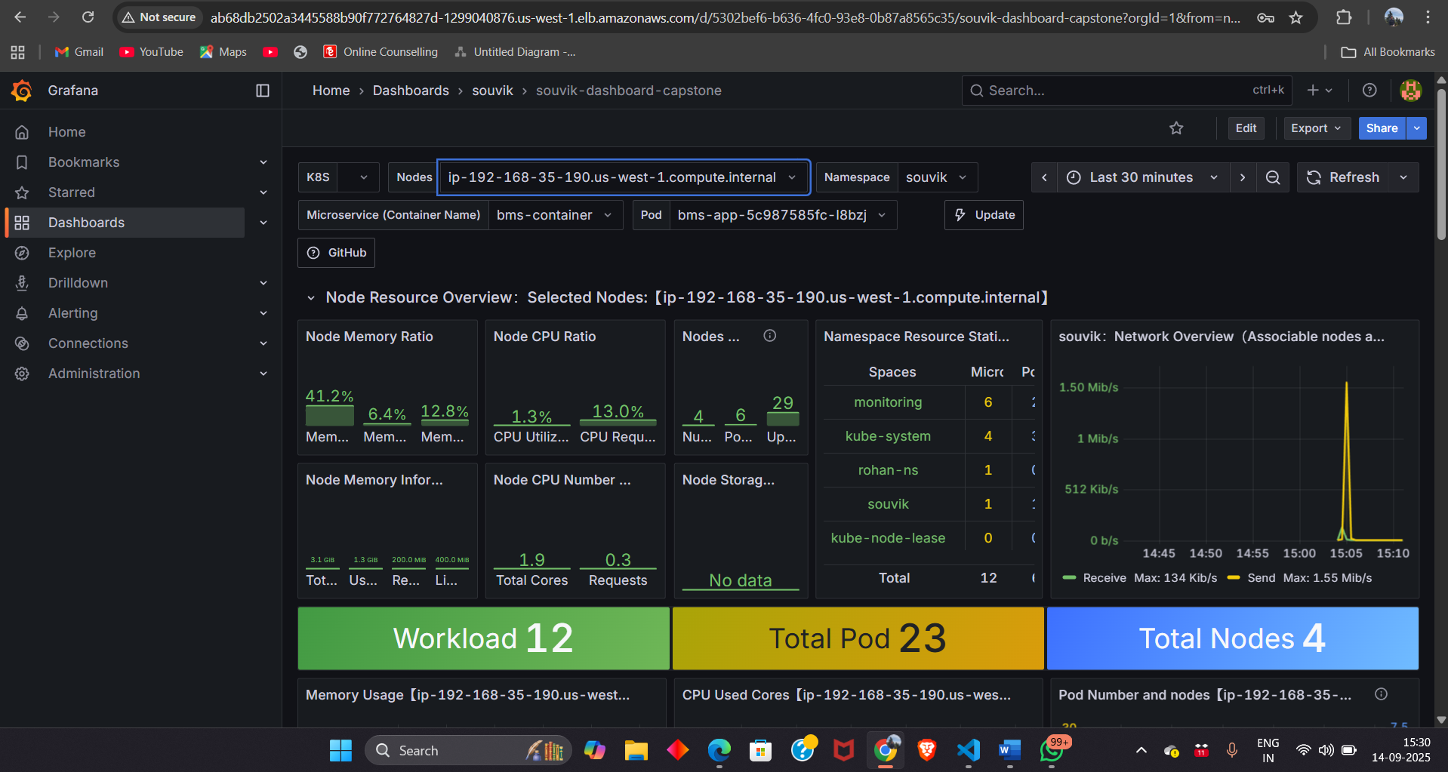
- After Prometheus login into Grafana and create a data source name = Prometheus
- Then either import a dashboard or create it
- After that select the designated pod and namespace to see the metrics
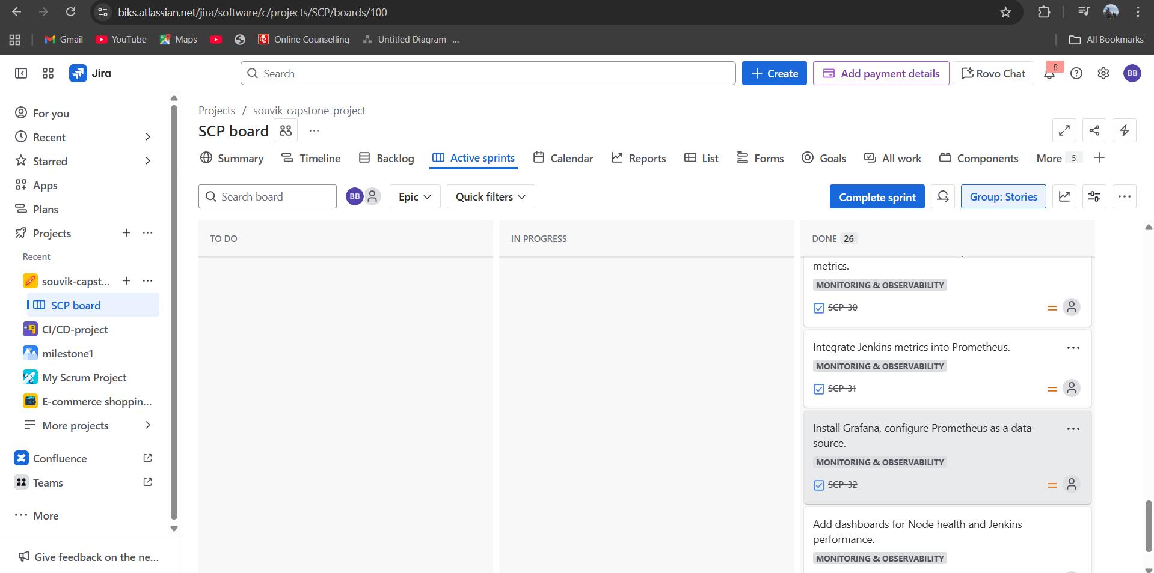
Finally, after completing the whole project complete the sprint and see the report.

Thank You

